How to Send report through email in Selenium Webdriver

September 28, 2016 by [Mukesh Otwani](http://learn-automation.com/author/mukesh50/) [37 Comments](http://learn-automation.com/send-report-through-email-in-selenium-webdriver/#comments)

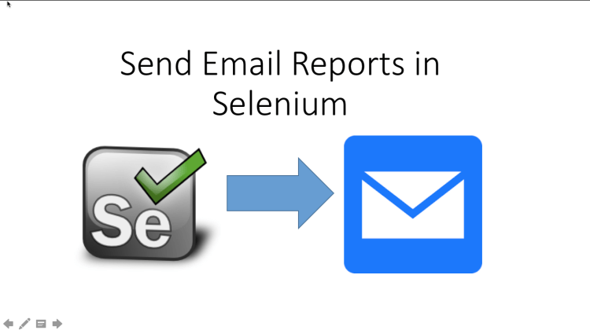

Do you know that we can Send report through email in Selenium Webdriver with small code with help of additional jars?

Today I will show you how you can Send [report](http://learn-automation.com/advance-selenium-reporting-with-screenshots-2/) through email in Selenium Webdriver using simple steps and trust me this is one of the most important features that you should include in your framework as well.

***It does not matter which framework you are using it could be Keyword driver,***[*Data driven*](http://learn-automation.com/data-driven-framework-in-selenium-webdriver/)***and Hybrid you should implement email report functionality after test execution.***

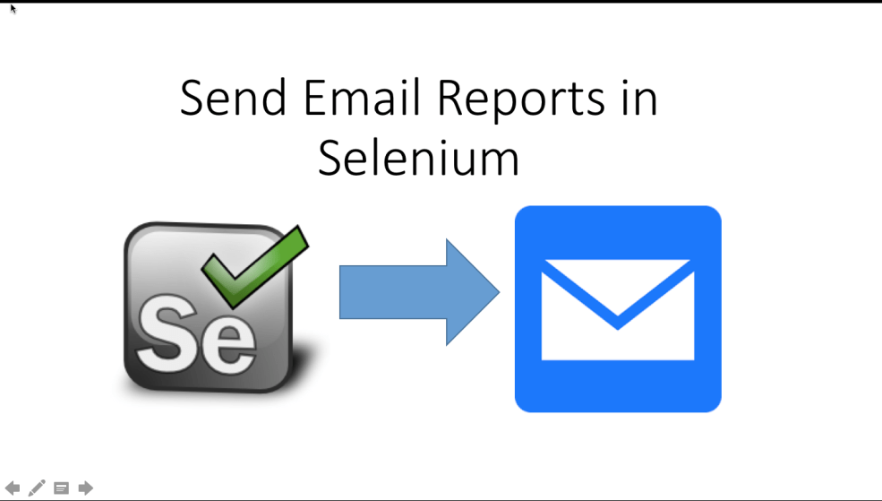

Step by Step process to Send report through email in Selenium Webdriver

1. Download [java mail jar file](https://mvnrepository.com/artifact/javax.mail/javax.mail-api/1.5.5)which contains the library to send the email.
2. 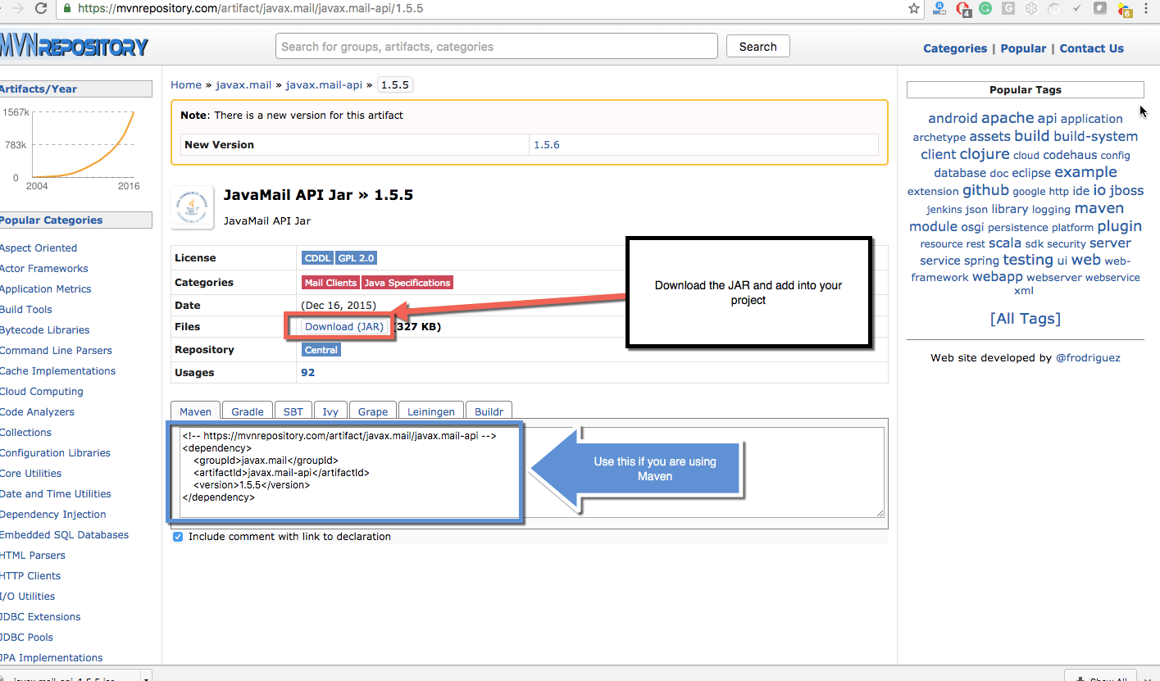
3. Add jar into your project and if you are working with [maven project](http://learn-automation.com/maven-integration-with-selenium/) then you can use dependency.
4. Be ready with the file which you want to send. In our case, it will be Selenium Report.
5. Write program, which will send the email to the team or a specific person.

Complete program to Send report through email in Selenium Webdriver



|  |  |
| --- | --- |
| 1  2  3  4  5  6  7  8  9  10  11  12  13  14  15  16  17  18  19  20  21  22  23  24  25  26  27  28  29  30  31  32  33  34  35  36  37  38  39  40  41  42  43  44  45  46  47  48  49  50  51  52  53  54  55  56  57  58  59  60  61  62  63  64  65  66  67  68  69  70  71  72  73  74  75  76  77  78  79  80  81  82  83  84  85  86  87  88  89  90  91  92  93  94  95  96  97  98  99  100  101  102  103  104  105  106  107  108  109  110  111  112  113  114  115 | package macSelenium;    import java.util.Properties;    import javax.activation.DataHandler;  import javax.activation.DataSource;  import javax.activation.FileDataSource;  import javax.mail.BodyPart;  import javax.mail.Message;  import javax.mail.MessagingException;  import javax.mail.Multipart;  import javax.mail.PasswordAuthentication;  import javax.mail.Session;  import javax.mail.Transport;  import javax.mail.internet.InternetAddress;  import javax.mail.internet.MimeBodyPart;  import javax.mail.internet.MimeMessage;  import javax.mail.internet.MimeMultipart;    public class SendMailSSLWithAttachment {    public static void main(String[] args) {    // Create object of Property file  Properties props = new Properties();    // this will set host of server- you can change based on your requirement  props.put("mail.smtp.host", "smtp.gmail.com");    // set the port of socket factory  props.put("mail.smtp.socketFactory.port", "465");    // set socket factory  props.put("mail.smtp.socketFactory.class","javax.net.ssl.SSLSocketFactory");    // set the authentication to true  props.put("mail.smtp.auth", "true");    // set the port of SMTP server  props.put("mail.smtp.port", "465");    // This will handle the complete authentication  Session session = Session.getDefaultInstance(props,    new javax.mail.Authenticator() {    protected PasswordAuthentication getPasswordAuthentication() {    return new PasswordAuthentication("add your email", "add your password");    }    });    try {    // Create object of MimeMessage class  Message message = new MimeMessage(session);    // Set the from address  message.setFrom(new InternetAddress("mukeshotwani.50@gmail.com"));    // Set the recipient address  message.setRecipients(Message.RecipientType.TO,InternetAddress.parse("mukesh.otwani50@gmail.com"));                            // Add the subject link  message.setSubject("Testing Subject");    // Create object to add multimedia type content  BodyPart messageBodyPart1 = new MimeBodyPart();    // Set the body of email  messageBodyPart1.setText("This is message body");    // Create another object to add another content  MimeBodyPart messageBodyPart2 = new MimeBodyPart();    // Mention the file which you want to send  String filename = "G:\\a.xlsx";    // Create data source and pass the filename  DataSource source = new FileDataSource(filename);    // set the handler  messageBodyPart2.setDataHandler(new DataHandler(source));    // set the file  messageBodyPart2.setFileName(filename);    // Create object of MimeMultipart class  Multipart multipart = new MimeMultipart();    // add body part 1  multipart.addBodyPart(messageBodyPart2);    // add body part 2  multipart.addBodyPart(messageBodyPart1);    // set the content  message.setContent(multipart);    // finally send the email  Transport.send(message);    System.out.println("=====Email Sent=====");    } catch (MessagingException e) {    throw new RuntimeException(e);    }    }    } |

*Above program will send the report to the respective recipient with the attachment.*

*You can also send  the*email*via Jenkins which is quite easy but you are not using Jenkins then you can use above program.*

Important points

1- You can create a custom library which should accept recipients as arguments so that we can reuse this as much we can.

2- Write the logic to get the path of the report, so that we can set the same in our methods.

3- Always call this code after test execution. You can use @AfterSuite of [TestNG](http://learn-automation.com/testng-tutorials-for-beginners/) which run only when complete suite execute.

Conclusion

1- Sending reports after every execution is very important but if you are running multiple tests in one day better to send combined reports at once.

2-Try to keep all screenshot in a common location where everyone will have access so when they click on report and screenshot then it should be accessible.

I hope you liked above article on Send report through email in Selenium Webdriver.

Please try from your side as well and let me know if any thoughts on this.